KQL Guide for SOC Analysts
From Beginner to Advance level
Table of Content:
- Introduction
- Free Resources
- Basics of KQL
- KQL Scenario Screenshots
- KQL Database

Introduction:
Kusto Query Language (KQL) is a powerful tool to explore your data and discover patterns, identify anomalies and outliers, create statistical modeling, and more. KQL is a simple yet powerful language to query structured, semi-structured, and unstructured data. The language is expressive, easy to read and understand the query intent, and optimized for authoring experiences. KQL is a powerful query language developed by Microsoft. It is primarily used for querying and analyzing large datasets stored in Azure Data Explorer and other Microsoft services, such as:
- Azure Monitor
- Log Analytics
- Application Insights
- Microsoft Sentinel

Key Features of KQL:
- Read-Only: KQL is used for data querying, not for modifying data.
- High Performance: Optimized for fast querying of large datasets.
- SQL-Like Syntax: While it is distinct from SQL, it shares some similarities in syntax, such as the use of commands like where, summarize, and join.
- Rich Functionality: Supports advanced filtering, aggregations, time-series analysis, and machine learning models.
- Visualization Support: Allows direct integration with visualizations like tables, charts, and dashboards.

Common Uses of KQL:
- Log Analysis: Analyzing logs from applications, services, or infrastructure.
- Security Monitoring: Used in tools like Microsoft Sentinel for threat detection.
- Diagnostics: Debugging and monitoring performance issues.
- Insights: Building dashboards and reports for business or IT data.

Free Resources:
There are tons of free resources out there on internet to learn KQL but some of the free resources and playgrounds to practice your KQL skills are as follow:
Resources:
Youtube:
This playlist is personally recommended and beginner friendly:
https://www.youtube.com/watch?v=EDCBLULjtCM
KQL cheat-sheet Github:
https://github.com/marcusbakker/KQL/blob/master/kql_cheat_sheet.pdf
Microsoft Official Documentation:
https://learn.microsoft.com/en-us/kusto/query/?view=microsoft-fabric
Google: You can use simple google tricks to extract different cheat-sheets and pdf files through following commands:
KQL site:github.com
KQL site:drive.google.com
KQL site:medium.com
KQL filetype:pdf
AI Generators:
KqlSearch: This is a lab based environment to generate different kql queries by giving the simple commands.
https://www.kqlsearch.com/querygenerator
YesChat: AI KQL generator, but remember not to provide any customer’s data (email, IP, device name etc.) instead you can provide this data in IP Address: x.x.x.x format or Device: xyz or email: abc@xyz.com.
https://www.yeschat.ai/gpts-9t55QeJzQMq-Sentinel-KQL-Builder
ChatGpt: We all are familiar with Chatgpt usage but never provide customer’s data as explained above. Instead you can ask chatgpt to generate queires based on your requirements and in case you are facing an error in result you can simply copy paste the error in chatgpt prompt to make some changes accordingly.
Playgrounds:
Microsoft Log Analytics Demo: This is an official playground site with some tables and data inside to practice you KQL skills. You have to login with any of you Microsoft Account (Personal, company’s account).
aka.ms/lademo

KC7 – KQL Game: This scenario based game is awesome and addictive and a best way to start as a beginner:
https://kc7cyber.com/
Detective Kusto – Advance level game: This is another game for medium to advance level to practice different scenarios.
https://detective.kusto.io/

Basics of KQL:
Before diving into the basics of KQL you must learn that during an investigation, where you can write and execute you KQL queries to find insights into the data.
KQL Execution tabs/Options:
If you are in sentinel then you have different tabs and options to write and execute your queries
1. Logs: Azure Portal -> Sentinel -> Logs
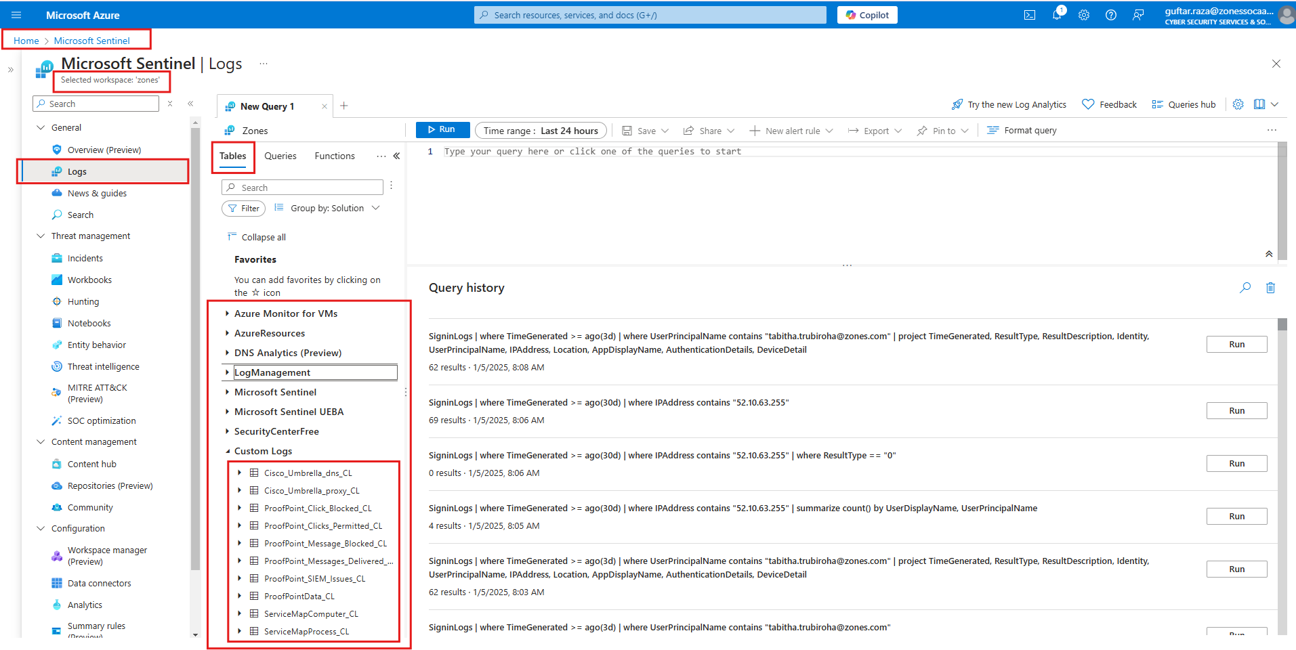

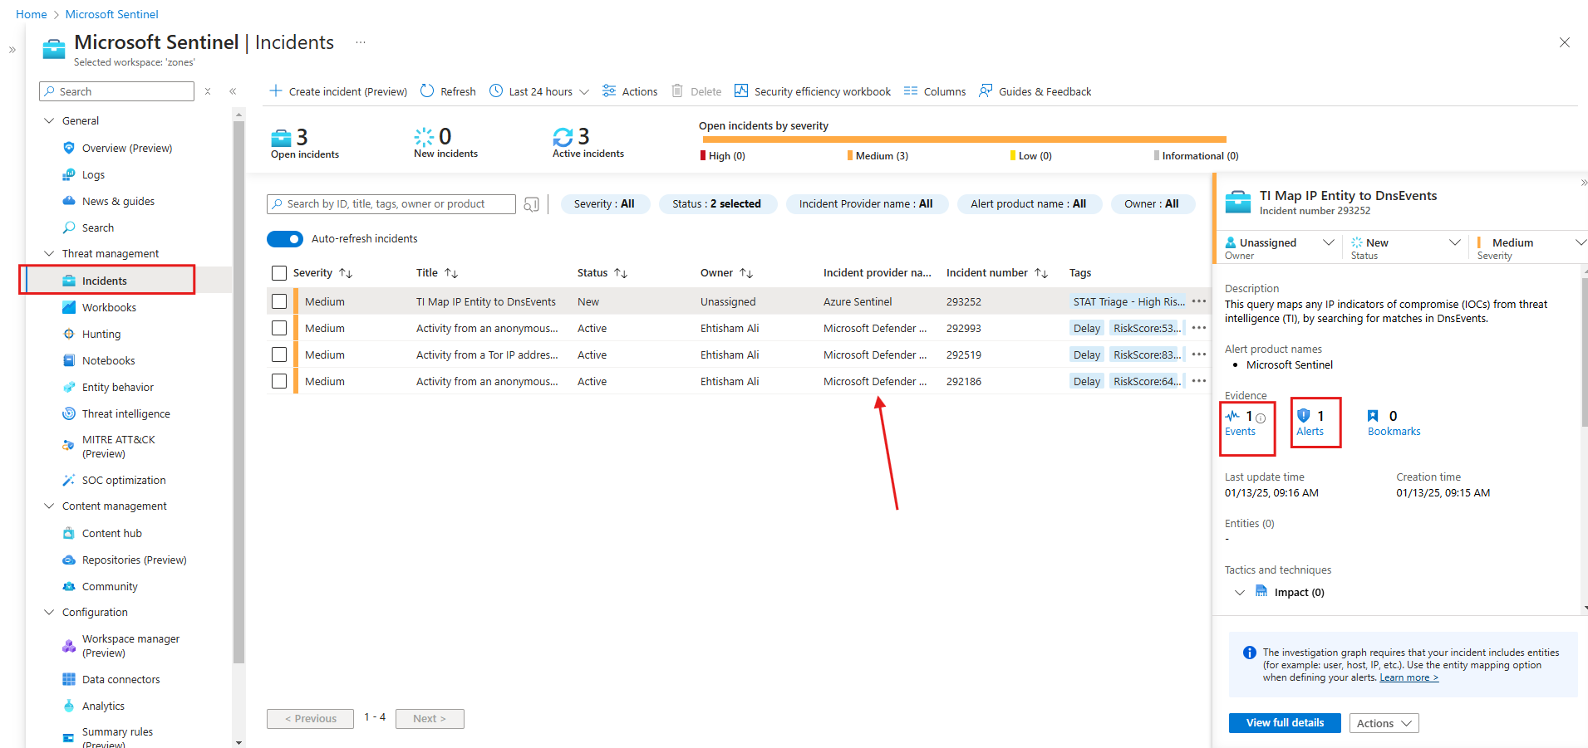

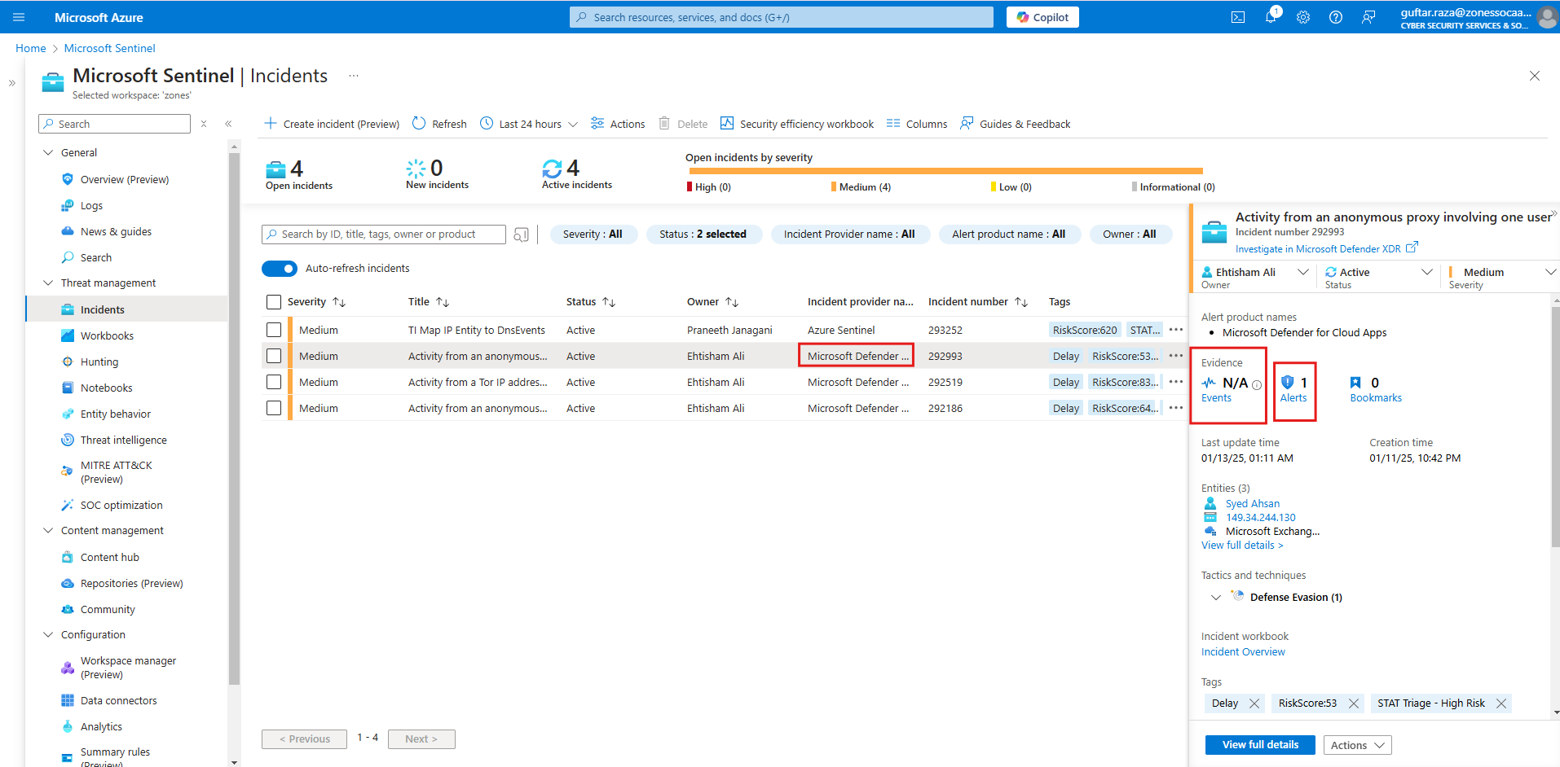
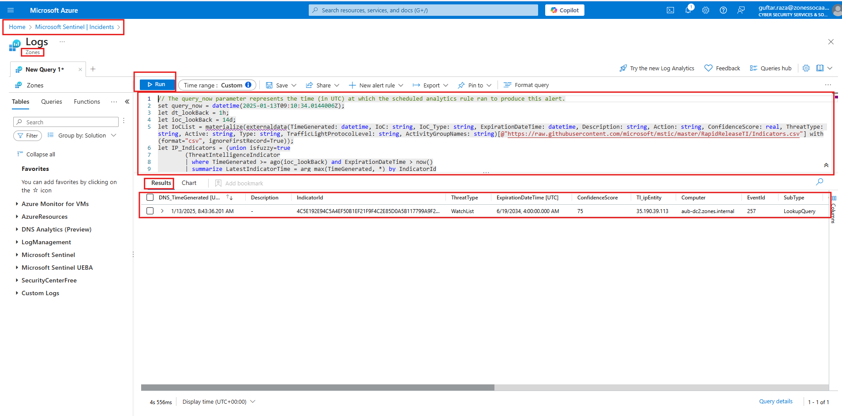

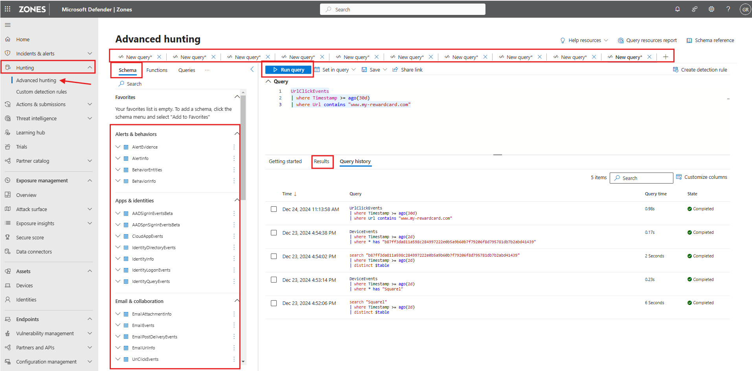

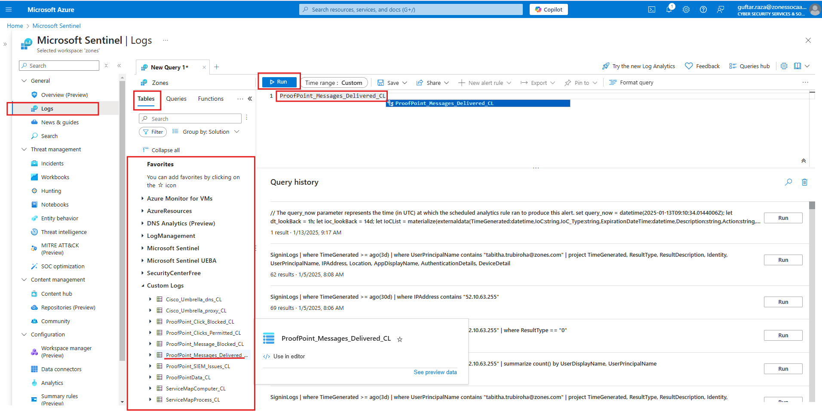
KQL Tables Availability:
Remember this that the availability of Tables depends upon:
i) License/Subscription being used (For example you will see more tables for a customer using E5 License rather than a customer using E3 or some other license).
ii) The data being ingested from different sources or 3rd party sources (For example TI, Proofpoint, Cisco etc.)

KQL Scenario Screenshots:
This is just an example of real time incident scenario to make analyst familiar with the procedure of hunting through KQL.
1.When you will open the incident in full view you will see some data in terms of incident name, alert(s) associated with the incident and entities which are part of that particular incident as shown below:
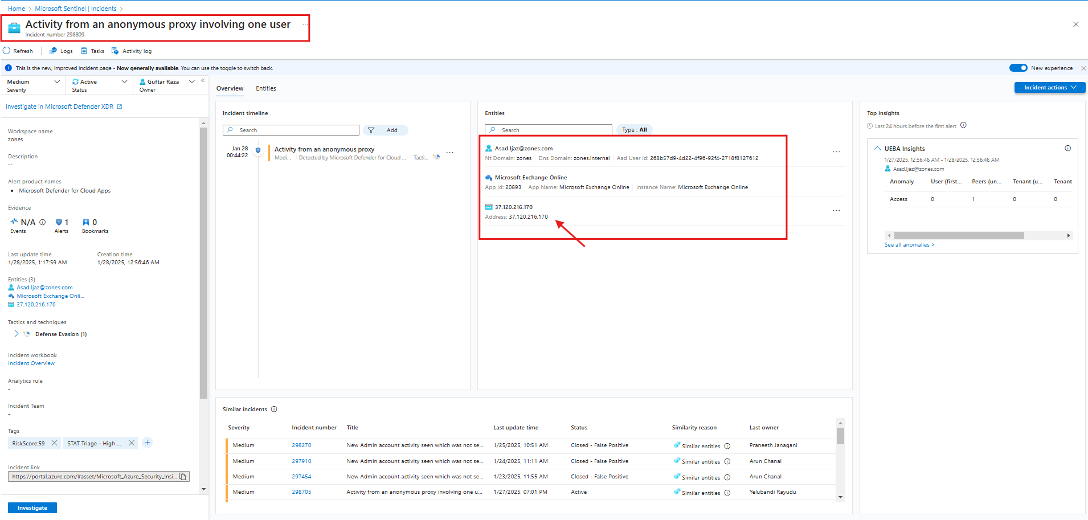
2. With the help of search operator you can start your hunting within given time range to see the entity presence in specific tables. In this example we have copied IP address to see it’s presence in tables for the last 30 days.
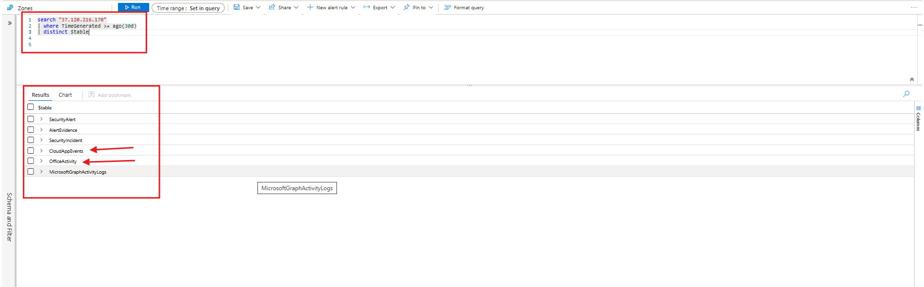
3.After getting the tables, you can start further hunting in relevant tables. We are further gonna hunt CloudAppsEvents and OfficeActivity tables as these will give us some information about the entity we are searching inside those tables.

4.Here in CloudAppsEvents table we can see that the user accessed some emails using this IP address as shown below:
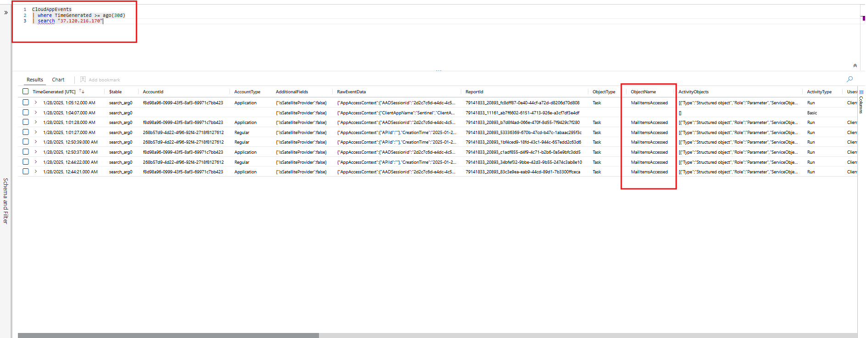
5.OfficeActivity table is also giving the almost same information about emails being accessed from that particular IP address:
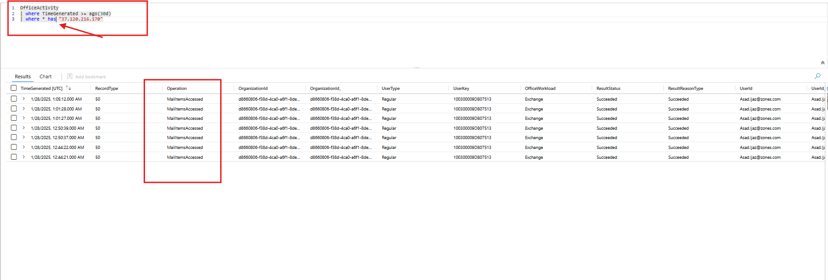
ProofPoint scenario:
For proofpoint scenario where the detection is due to Sentinel Analytics we will follow these steps to hunt through KQL:
1.We got 3 events by Sentinel Analytics where we can see the relevant data. We will click “Events” to see the data.
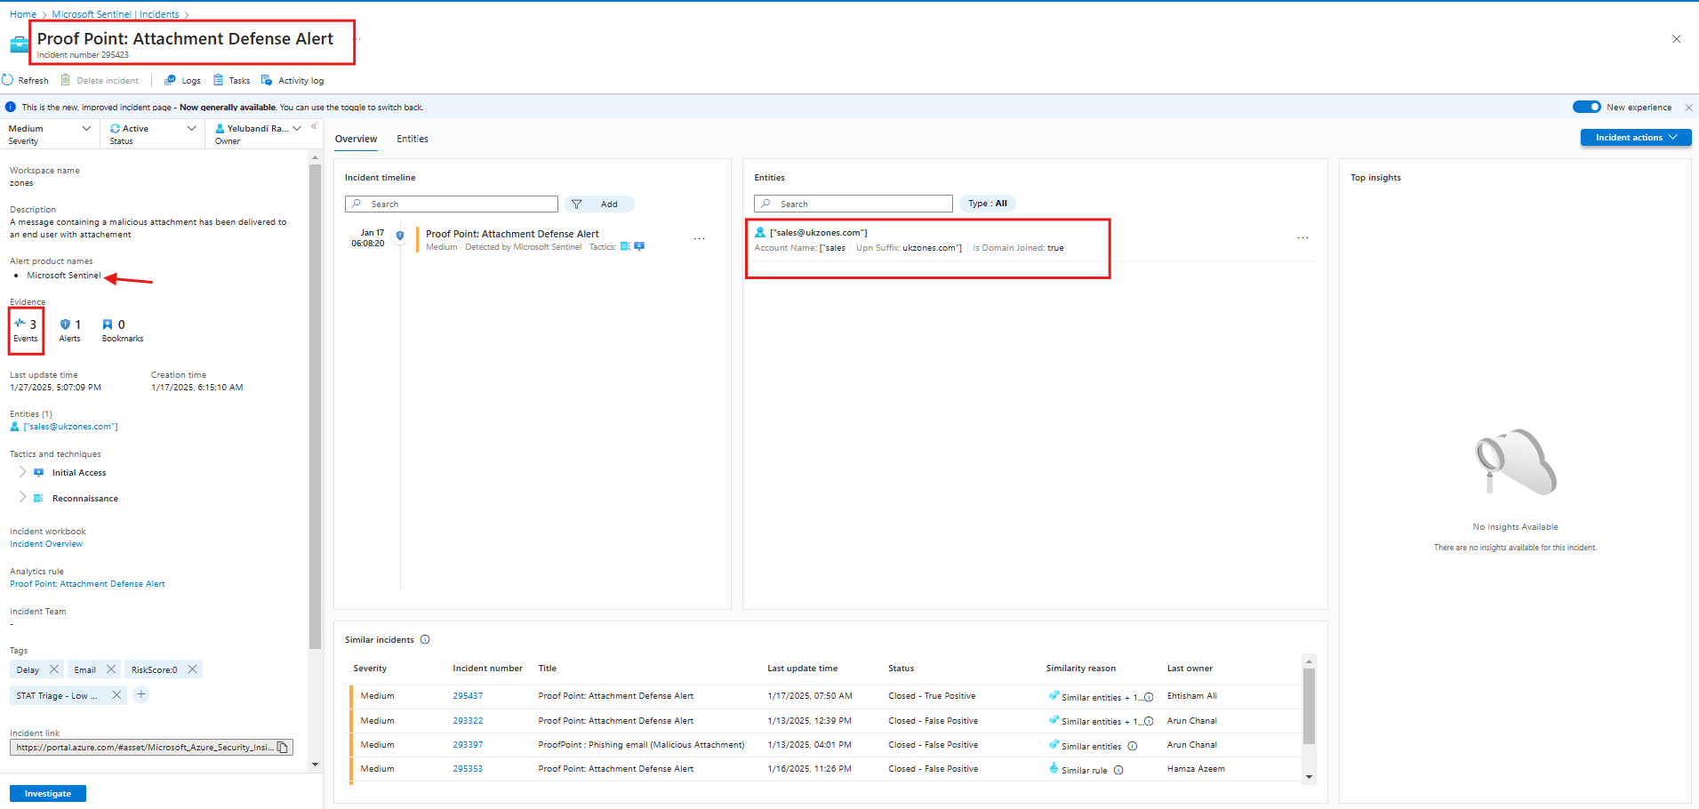
2.After clicking on Events, we can see the details:
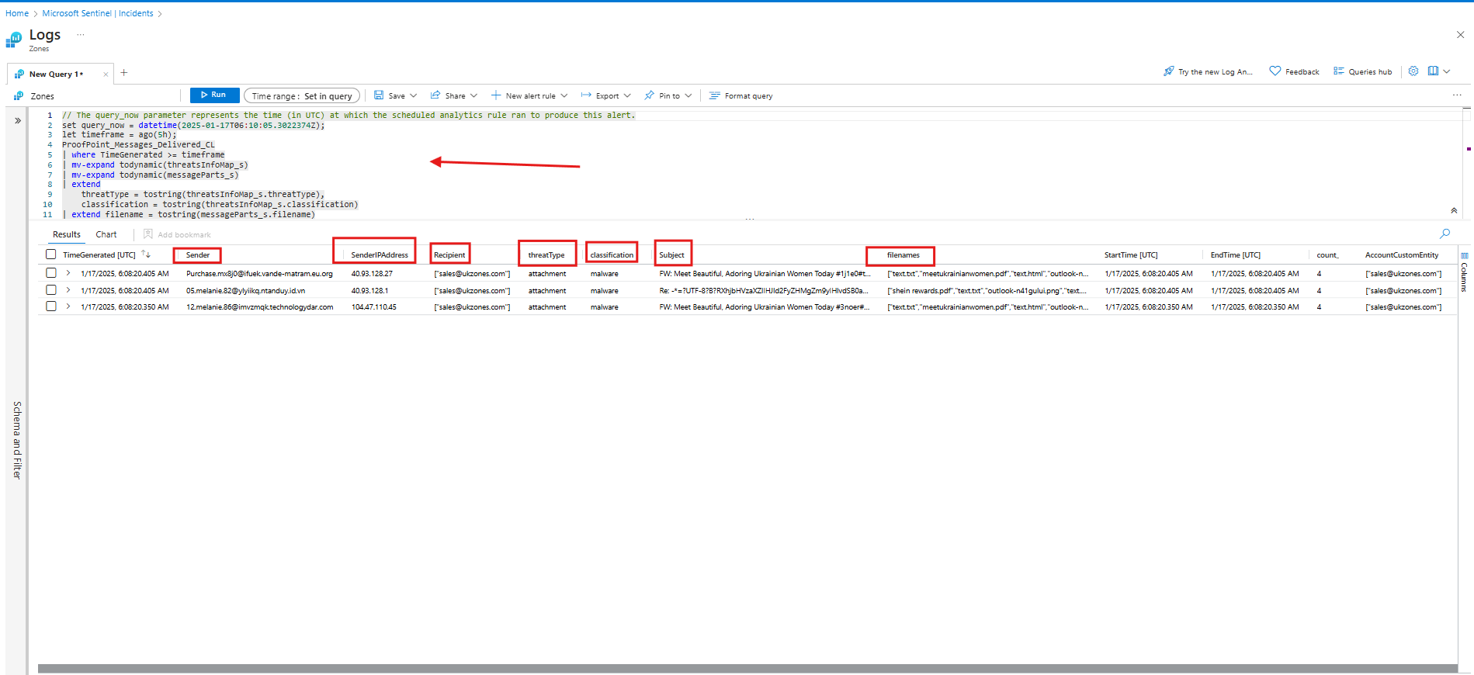
3.As the detection was related to proofpoint, we will search for the all tables related to proofpoint by writing some initials as shown:
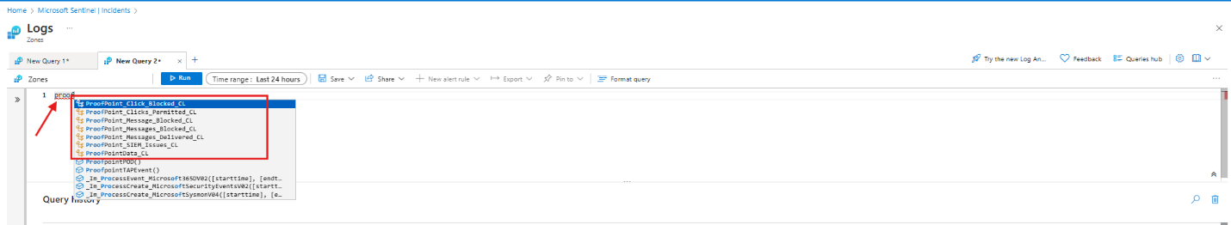
4.We can query a single table against our input for example sender which we are using in this case:
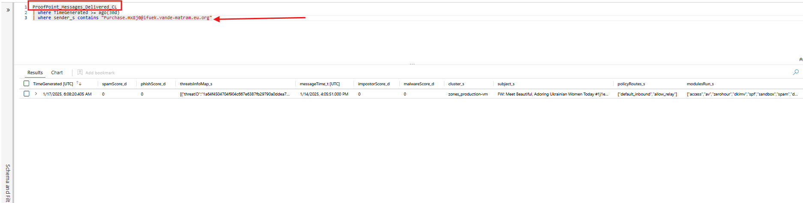
5.We can “union” all the tables of proofpoint and can search to see whether the email was blocked after delivery, was there any URL click etc.
We just got ProofPoint_Message_Delivered_CL which means that the email was just delivered and email wasn’t blocked by proofpoint and there isn’t any URL click (permitted or blocked):
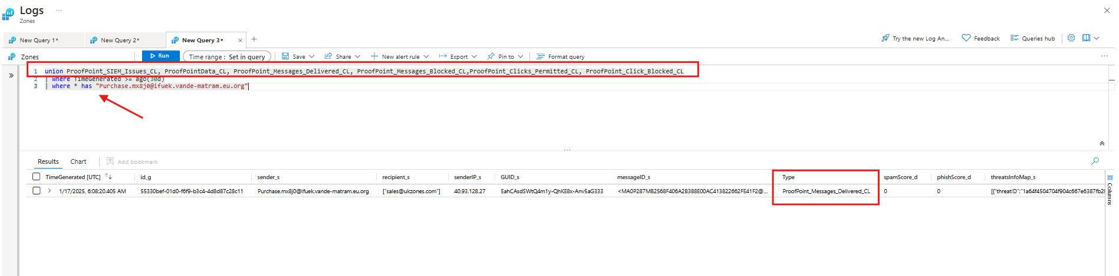

KQL Database:
This section contains detailed KQL queries for different scenarios starting from scratch to covering different products like: Identity, Email, Office etc:
General Basic Queries

search "Anything <IP>, <FileName>,<Filehashes>, <Username>, <UPN>, <any string>"
| where TimeGenerated >= ago(30d) //you can change the time based upon your requirement i.e: (15m), (3h), (7d)
| distinct $table //This will display the tables in which that entitiy was seen in given timeframe. Then you can further research inside those tables to investigate.

IDENTITY
SigninLogs
| where TimeGenerated >= ago(30d)
| where UserPrincipalName contains "Paste UPN here"
| summarize count() by IPAddress, Location //This will give you the count by IP address and location, so to get a basic idea of usual location

//Query to see the IP usage in organization by the users in last 30 days.
SigninLogs
| where TimeGenerated >= ago(30d)
| where IPAddress contains ""
| summarize count() by UserDisplayName, UserPrincipalName

//Remove comment bars according to the need of usage and requirement
union SigninLogs, AADNonInteractiveUserSignInLogs
| where TimeGenerated >= ago(30d)
//| where UserPrincipalName contains "" // paste a specific UPN
//| summarize count() by IPAddress, Location //to see the usual IP and location of a user
//| where IPAddress contains "" //paste an IP
//| summarize count() by UserDisplayName, UserPrincipalName // to see the IP usage by different users in organization

SigninLogs
| where UserPrincipalName contains ""
| project TimeGenerated, ResultType, Identity, UserPrincipalName, IPAddress, Location ,AuthenticationDetails, DeviceDetail

union SigninLogs, aadNonInteractiveSignins
| where IPAddress contains ""
//| where UserPrincipalName contains ""

//User's usual location
SigninLogs
| where TimeGenerated >= ago(30d)
| where UserPrincipalName contains ""
| distinct TimeGenerated, IPAddress, Location

// check the other users in org using the same IP
SigninLogs
| where TimeGenerated >= ago(30d)
| where IPAddress contains ""
| distinct TimeGenerated, UserDisplayName, UserPrincipalName

//detailed comparison
SigninLogs
| where TimeGenerated >= ago(30d)
| where UserPrincipalName contains ""
| project TimeGenerated,Identity, IPAddress, Location ,AlternateSignInName ,ResultType, ResultDescription, DeviceDetail ,UserAgent,AppDisplayName, AuthenticationDetails, MfaDetail ,AuthenticationRequirement, ConditionalAccessPolicies, ConditionalAccessStatus, NetworkLocationDetails, RiskDetail, RiskEventTypes, RiskEventTypes_V2, RiskLevel

//Detailed query to check sign-in logs
SigninLogs
//Include the UPN user@domain or nameoftheuser - replaced "==" for "contains"
| where UserPrincipalName contains ""
//Time range has been increased to 15 days
| where TimeGenerated > ago(60d)
//added ResultType == "50140" or ResultType == "50125"; which reflect other types of successful sign-in events
//| where ResultType == "0" or ResultType == "50140" or ResultType == "50125"
| extend browser_ = tostring(DeviceDetail.browser)
| extend operatingSystem_ = tostring(DeviceDetail.operatingSystem)
| extend state_ = tostring(LocationDetails.state)
| extend city_ = tostring(LocationDetails.city)
| extend country_ = tostring(LocationDetails.countryOrRegion)
| extend device_ = tostring(DeviceDetail.displayName)
| extend authenticationStepResultDetail_ = tostring(parse_json(AuthenticationDetails)[1].authenticationStepResultDetail)
| extend authenticationMethod_ = tostring(parse_json(AuthenticationDetails)[1].authenticationMethod)
//added MFA, ResourceDisplayName, error code and error description
| project TimeGenerated, IPAddress, city_, state_, country_, ResourceDisplayName, SystemName_, AppDisplayName, browser_, operatingSystem_, UserAgent, AuthenticationRequirement,authenticationStepResultDetail_, authenticationMethod_,ResultType, ResultDescription
| sort by TimeGenerated

//User Agent Check BAV2ROPC
SigninLogs
//Include the UPN user@domain or nameoftheuser - replaced "==" for "contains"
| where UserPrincipalName contains ""
//Time range has been increased to 15 days
| where TimeGenerated >= ago(30d)
//added ResultType == "50140" or ResultType == "50125"; which reflect other types of successful sign-in events
//| where ResultType == "0" or ResultType == "50140" or ResultType == "50125"
| extend browser_ = tostring(DeviceDetail.browser)
| extend operatingSystem_ = tostring(DeviceDetail.operatingSystem)
| extend state_ = tostring(LocationDetails.state)
| extend city_ = tostring(LocationDetails.city)
| extend country_ = tostring(LocationDetails.countryOrRegion)
| extend SystemName_ = tostring(DeviceDetail.displayName)
//added MFA, ResourceDisplayName, error code and error description
| project TimeGenerated, city_, state_, country_, ResourceDisplayName, SystemName_, AppDisplayName, browser_, operatingSystem_, UserAgent, IPAddress, AuthenticationRequirement, ResultType, ResultDescription,MfaDetail
//| sort by TimeGenerated
| summarize count() by UserAgent, ResultType, ResultDescription

//Detailed sign-ins
SigninLogs
| where TimeGenerated >= ago(30d)
| where IPAddress contains ""
| extend Device_name = tostring(DeviceDetail.displayName)
| extend authenticationMethod_ = tostring(parse_json(AuthenticationDetails)[1].authenticationMethod)
| extend authenticationMethod_ = tostring(parse_json(AuthenticationDetails)[1].authenticationMethod)
| extend authenticationStepRequirement_ = tostring(parse_json(AuthenticationDetails)[1].authenticationStepRequirement)
| extend authenticationStepResultDetail_ = tostring(parse_json(AuthenticationDetails)[1].authenticationStepResultDetail)
| extend succeeded_ = tostring(parse_json(AuthenticationDetails)[1].succeeded)
| project UserPrincipalName , DeviceDetail, AuthenticationDetails, Device_name, authenticationMethod_, authenticationStepResultDetail_, succeeded_

SigninLogs
| where TimeGenerated >= ago(30d)
| where UserPrincipalName contains ""
| extend Device_name = tostring(DeviceDetail.displayName)
| extend authenticationMethod_ = tostring(parse_json(AuthenticationDetails)[1].authenticationMethod)
| extend authenticationMethod_ = tostring(parse_json(AuthenticationDetails)[1].authenticationMethod)
| extend authenticationStepRequirement_ = tostring(parse_json(AuthenticationDetails)[1].authenticationStepRequirement)
| extend authenticationStepResultDetail_ = tostring(parse_json(AuthenticationDetails)[1].authenticationStepResultDetail)
| extend succeeded_ = tostring(parse_json(AuthenticationDetails)[1].succeeded)
| project TimeGenerated,IPAddress, Location , DeviceDetail, AuthenticationDetails, Device_name, authenticationMethod_, authenticationStepResultDetail_, succeeded_

User Agent:
union SigninLogs, AADNonInteractiveUserSignInLogs
| where UserPrincipalName contains ""
| where UserAgent contains ""
| project TimeGenerated, OperationName, Category, Identity,AppDisplayName, DeviceDetail_string, IPAddress

SigninLogs | where IPAddress == “” | project-reorder TimeGenerated, IPAddress, UserPrincipalName
AADNonInteractiveUserSignInLogs | where IPAddress == “” | distinct UserPrincipalName, IPAddress | project-reorder IPAddress, UserPrincipalName

EMAILS

union EmailEvents, EmailUrlInfo, EmailAttachmentInfo //Union all the email related tables to see the whole information about a specific email filtered by Network Message ID.
| where TimeGenerated >= ago(30d)
| where NetworkMessageId contains "Paste Network Message ID here"//The network message ID will be the same for an email in all 3 //tables
// You can filter out with any filter, senderFromAddress, SenderfromDomain, SenderIP, Subject etc.
// you can project details based upon your needs like project TimeGenerated, DeliveryAction, DeliveryLocation, EmailDirection, URL etc.

OfficeActivity
| where TimeGenerated >= ago(30d)
| where * has "Internet Message ID here"//paste internet message ID here to see whether the email was was accessed, moved to deleted items folder and different other operations.

EmailEvents | where TimeGenerated >= ago(220d) | where SenderFromAddress contains "[Domain.com]" | render columnchart

//Search through NetworkMessageID
EmailEvents
| where TimeGenerated >= ago(30d)
| where NetworkMessageId contains ""

//Email whole information
union EmailEvents, EmailAttachmentInfo, EmailUrlInfo
| where TimeGenerated >= ago(30d)
| where NetworkMessageId contains ""
| project TimeGenerated, RecipientEmailAddress, Subject, SenderDisplayName, SenderFromAddress, SenderFromDomain, SenderIPv4, UrlCount, AttachmentCount, Url, FileName, FileType

let NetworkMsgId = "";
EmailEvents
| where NetworkMessageId has NetworkMsgId and TimeGenerated > ago(3d)
| join kind=leftouter (EmailUrlInfo| where NetworkMessageId has NetworkMsgId) on NetworkMessageId
| join kind=leftouter (EmailAttachmentInfo| where NetworkMessageId has NetworkMsgId) on NetworkMessageId
| join kind=leftouter (UrlClickEvents | where NetworkMessageId has NetworkMsgId | project ActionType, urlclicked = Url, NetworkMessageId) on NetworkMessageId
| distinct TimeGenerated, RecipientEmailAddress, SenderFromAddress, SenderDisplayName, Subject, AttachmentCount, DeliveryAction, DeliveryLocation, Url, UrlCount, ActionType, urlclicked, AuthenticationDetails, FileName, FileSize, FileType, SHA256, SenderIPv4, InternetMessageId, SenderMailFromAddress

//Mail Access or not
OfficeActivity
| where TimeGenerated >= ago(30d)
| where Operation contains "MailItemsAccessed"
| where MailboxOwnerUPN contains ""

EmailUrlInfo
| where TimeGenerated >= ago(30d)
//| where NetworkMessageId == ""

EmailEvents
| where EmailDirection == "Inbound"
//Add in your malicious subject or malicious sender address
| where Subject == "Malicious Subject Name" or SenderFromAddress == "malicioususer@domain.com"
| project RecipientEmailAddress, Subject, InternetMessageId, SenderFromAddress
//Combine that data with the OfficeActivity table which tracks whether an email was accessed
| join kind=inner (
OfficeActivity
| where Operation == "MailItemsAccessed"
| mv-expand todynamic(Folders)
| extend FolderItems = Folders.FolderItems
| mv-expand FolderItems
| extend InternetMessageId = tostring(FolderItems.InternetMessageId)
| project UserId, InternetMessageId
)
on InternetMessageId
//Create summary of data listing the count and all the users who received the email vs the list and count of those that read it
| summarize
['Receipient Count']=dcount(RecipientEmailAddress),
['Users Who Received Email']=make_set(RecipientEmailAddress),
['Reader Count']=dcount(UserId),
['Users Who Read Email']=make_set(UserId)
by SenderFromAddress, Subject, InternetMessageId

OFFICE
OfficeActivity
| distinct Operation // This will show you all the operations inside office hundreds of actions and you can choose according to your need as the one given above for email to check whether it was accessed/soft deleted etc. with the help of Internet Message ID of email

OfficeActivity
| where Operation contains "mail"//To see all the operations related to Mail i.e: mailItemAccessed, MailitemDeleted, Add-MailboxPermissions, New-Mailbox, Remove-MailboxPermissions etc.

URL Click

//Query to see the total number of clicks in last 30 days
UrlClickEvents
| where TimeGenerated >= ago(30d)
| where Url contains "Paste URL here"

//Query to see the device on which URL click took place
DeviceEvents
| where TimeGenerated >= ago(30d)
| where * has "Paste URL here"

//Device process event for URL click details
DeviceProcessEvents
| where TimeGenerated >= ago(30d)
| where * has "Paste URL here"

//Union of above 3 where you just have to paste the URL and it will show you all the details of URL click and workload in which that specific URL was found
union UrlClickEvents, DeviceEvents, DeviceProcessEvents
| where TimeGenerated >= ago(30d)
| where * has "Paste URL here"

UrlClickEvents
| where ActionType == "ClickAllowed" or IsClickedThrough == "True"
|where Url has ""
|project TimeGenerated, ActionType, Url, IPAddress, ThreatTypes, IsClickedThrough, AccountUpn

// Search for malicious links where user was allowed to proceed through
UrlClickEvents
| where ActionType == "ClickAllowed" or IsClickedThrough !="0"
| where ThreatTypes has "Phish"
| summarize by ReportId, IsClickedThrough, AccountUpn, NetworkMessageId, ThreatTypes, Timestamp

UrlClickEvents
| where * has ""
|project TimeGenerated, Url, ActionType, AccountUpn, IPAddress, IsClickedThrough
|where TimeGenerated >= ago(30d)

HeartBeat

Use to build a pattern:
Datatable (CommonSecurityLog or Heartbeat or Syslog)
| where TimeGenerated >= ago(30d)
| where Computer == "AddIPorHostname"
| summarize count() by bin(TimeGenerated, 1d)

Syslog
| where TimeGenerated >= ago(30d)
| where Computer contains ""
| summarize count() by bin(TimeGenerated, 1d)
| render timechart

Use to locate the last log entry:
Heartbeat
| where TimeGenerated >= ago(30d)
| where Computer == "AddIPorHostname"
| summarize arg_max(TimeGenerated,*) by Computer

| sort by TimeGenerated desc

CommonSecurityLog//Syslog
| where * contains ""//the device name
| make-series count() on TimeGenerated from ago(1d) to now() step 10m
|render timechart

OR the simple one

Syslog
| where Computer contains ""

Deletion

OfficeActivity
| where * has ""
| where Operation contains "delete"

CloudAppEvents
| where * has ""
| where ActionType contains "delete"

CloudAppEvents
| where IPAddress contains ""
| where ActionType contains "delete"
| extend parsed= parse_json(RawEventData).ObjectId
| extend pasrsed1= parse_json(RawEventData).Application
| project parsed, pasrsed1

Tenant Allow/Block

CloudAppEvents
| where * has "SecurityComplianceEvent"
| where ActionType contains "TenantAllowBlockListItemExpiry"
| project RawEventData

CloudAppEvents
| where * has "SecurityComplianceEvent"
| where ActionType contains "TenantAllowBlockListItemExpiry"
| project RawEventData
| extend entity = tostring(parse_json(RawEventData.EntityData.Entity))
| extend expiry = tostring(parse_json(RawEventData.EntityData.Expiry))
| extend action = tostring(parse_json(RawEventData.TenantAllowBlockListItemExpiry.ItemAction))
| project entity, expiry, action

union
CloudAppEvents, OfficeActivity | where (Folders has 'INTERNETMESSAGEID' and Operation == 'MailItemsAccessed' and UserType == 'Regular') or (RawEventData has 'INTERNETMESSAGE' and AccountType == 'Regular' and ActionType == 'MailItemsAccessed')

EmailEvents
| where NetworkMessageId has ""
|project TimeGenerated, DeliveryLocation, SenderDisplayName, SenderFromAddress, SenderFromDomain, SenderMailFromAddress, SenderIPv4, Subject, RecipientEmailAddress, EmailAction, EmailDirection, DeliveryAction, InternetMessageId, AttachmentCount, UrlCount

EmailEvents
| where NetworkMessageId has " "
|project TimeGenerated, SenderDisplayName, SenderFromAddress, SenderFromDomain, SenderMailFromAddress, SenderIPv4, Subject, RecipientEmailAddress, EmailAction, EmailDirection, DeliveryAction, InternetMessageId, AttachmentCount, UrlCount

union SigninLogs, AADNonInteractiveUserSignInLogs
|where * has ""
|project TimeGenerated, IPAddress, UserPrincipalName, ResultType, ResultDescription, DeviceDetail_string, AppDisplayName, AuthenticationRequirement, UserAgent, AutonomousSystemNumber, Location

SecurityEvent
|where Computer has ""
//|where IpAddress has ""
|where EventID == "4624"
|distinct Account, IpAddress

********Suspected brute-force attack (LDAP) on multiple endpoints
IdentityQueryEvents
| where TimeGenerated >= ago(48h)
|where ActionType contains "LDAP"
|where IPAddress contains ""
|where DestinationDeviceName contains ""
|project TimeGenerated, ActionType, Query, QueryTarget, IPAddress, DestinationDeviceName, TargetAccountUpn
|sort by TimeGenerated

Proofpoint

ProofPointTAPMessagesDelivered_CL, ProofPointTAPMessagesBlocked_CL, ProofPointTAPClicksPermitted_CL, ProofPointTAPClicksBlocked_CL

// To investigate the delivered messages, (how many emails were sent into the org and etc)
ProofPointTAPMessagesDelivered_CL
//| where subject_s contains ""
//| where headerFrom_s contains ""
//| where senderIP_s contains ""

//Investigate the particular email whether got blocked or not
ProofPointTAPMessagesBlocked_CL
//| where sender_s contains ""
//| where subject_s contains "New important message is available online"
//| where senderIP_s contains ""

//Check permitted clicks through any of the filters
ProofPointTAPClicksPermitted_CL
//| where url_s contains ""
//| where sender_s contains ""
//| where senderIP_s contains ""

// Investigate whether the URL click was block using different filters
ProofPointTAPClicksBlocked_CL
//| where url_s contains ""
//| where sender_s contains ""
//| where senderIP_s contains ""

// use this for a whole overview
union ProofPointTAPMessagesDelivered_CL, ProofPointTAPMessagesBlocked_CL, ProofPointTAPClicksPermitted_CL, ProofPointTAPClicksBlocked_CL
| where TimeGenerated >= ago(90d)
| where senderIP_s contains ""
//| where sender_s contains ""
//| where subject_s contains ""
| extend table = Type, subject= subject_s, url = url_s, sender = sender_s, recipient = recipient_s

